**The challenges**

**Task 1**

Difficulty: Moderate

**Task 1.1**

In your company there hasn't been a database table with all the employee information yet.

You need to set up the table called employees in the following way:



There should be NOT NULL constraints for the following columns:

first_name,

last_name ,

job_position,

start_date DATE,

birth_date DATE

1. CREATE TABLE employees (
2. emp_id SERIAL PRIMARY KEY,
3. first_name TEXT NOT NULL,
4. last_name TEXT NOT NULL,
5. job_position TEXT NOT NULL,
6. salary decimal(8,2),
7. start_date DATE NOT NULL,
8. birth_date DATE NOT NULL,
9. store_id INT REFERENCES store(store_id),
10. department_id INT,
11. manager_id INT
12. );

**Task 1.2**

Set up an additional table called departments in the following way:



Additionally no column should allow nulls.

1. CREATE TABLE departments (
2. department_id SERIAL PRIMARY KEY,
3. department TEXT NOT NULL,
4. division TEXT NOT NULL);

**Task 2**

Difficulty: Moderate

Alter the employees table in the following way:

- Set the column department_id to not null.

- Add a default value of CURRENT_DATE to the column start_date.

- Add the column end_date with an appropriate data type (one that you think makes sense).

- Add a constraint called birth_check that doesn't allow birth dates that are in the future.

- Rename the column job_position to position_title.

1. ALTER TABLE employees
2. ALTER COLUMN department_id SET NOT NULL,
3. ALTER COLUMN start_date SET DEFAULT CURRENT_DATE,
4. ADD COLUMN end_date DATE,
5. ADD CONSTRAINT birth_check CHECK(birth_date < CURRENT_DATE);
6. ALTER TABLE employees
7. RENAME job_position TO position_title;

**Task 3**

Difficulty: Moderate

1. INSERT INTO employees
2. VALUES
3. (1,'Morrie','Conaboy','CTO',21268.94,'2005-04-30','1983-07-10',1,1,NULL,NULL),
4. (2,'Miller','McQuarter','Head of BI',14614.00,'2019-07-23','1978-11-09',1,1,1,NULL),
5. (3,'Christalle','McKenny','Head of Sales',12587.00,'1999-02-05','1973-01-09',2,3,1,NULL),
6. (4,'Sumner','Seares','SQL Analyst',9515.00,'2006-05-31','1976-08-03',2,1,6,NULL),
7. (5,'Romain','Hacard','BI Consultant',7107.00,'2012-09-24','1984-07-14',1,1,6,NULL),
8. (6,'Ely','Luscombe','Team Lead Analytics',12564.00,'2002-06-12','1974-08-01',1,1,2,NULL),
9. (7,'Clywd','Filyashin','Senior SQL Analyst',10510.00,'2010-04-05','1989-07-23',2,1,2,NULL),
10. (8,'Christopher','Blague','SQL Analyst',9428.00,'2007-09-30','1990-12-07',2,2,6,NULL),
11. (9,'Roddie','Izen','Software Engineer',4937.00,'2019-03-22','2008-08-30',1,4,6,NULL),
12. (10,'Ammamaria','Izhak','Customer Support',2355.00,'2005-03-17','1974-07-27',2,5,3,'2013-04-14'),
13. (11,'Carlyn','Stripp','Customer Support',3060.00,'2013-09-06','1981-09-05',1,5,3,NULL),
14. (12,'Reuben','McRorie','Software Engineer',7119.00,'1995-12-31','1958-08-15',1,5,6,NULL),
15. (13,'Gates','Raison','Marketing Specialist',3910.00,'2013-07-18','1986-06-24',1,3,3,NULL),
16. (14,'Jordanna','Raitt','Marketing Specialist',5844.00,'2011-10-23','1993-03-16',2,3,3,NULL),
17. (15,'Guendolen','Motton','BI Consultant',8330.00,'2011-01-10','1980-10-22',2,3,6,NULL),
18. (16,'Doria','Turbat','Senior SQL Analyst',9278.00,'2010-08-15','1983-01-11',1,1,6,NULL),
19. (17,'Cort','Bewlie','Project Manager',5463.00,'2013-05-26','1986-10-05',1,5,3,NULL),
20. (18,'Margarita','Eaden','SQL Analyst',5977.00,'2014-09-24','1978-10-08',2,1,6,'2020-03-16'),
21. (19,'Hetty','Kingaby','SQL Analyst',7541.00,'2009-08-17','1999-04-25',1,2,6,NULL),
22. (20,'Lief','Robardley','SQL Analyst',8981.00,'2002-10-23','1971-01-25',2,3,6,'2016-07-01'),
23. (21,'Zaneta','Carlozzi','Working Student',1525.00,'2006-08-29','1995-04-16',1,3,6,'2012-02-19'),
24. (22,'Giana','Matz','Working Student',1036.00,'2016-03-18','1987-09-25',1,3,6,NULL),
25. (23,'Hamil','Evershed','Web Developper',3088.00,'2022-02-03','2012-03-30',1,4,2,NULL),
26. (24,'Lowe','Diamant','Web Developper',6418.00,'2018-12-31','2002-09-07',1,4,2,NULL),
27. (25,'Jack','Franklin','SQL Analyst',6771.00,'2013-05-18','2005-10-04',1,2,2,NULL),
28. (26,'Jessica','Brown','SQL Analyst',8566.00,'2003-10-23','1965-01-29',1,1,2,NULL);

**Task 3.1**

Insert the following values into the *employees*table.

There will be most likely an error when you try to insert the values.

So, try to insert the values and then fix the error.

*Columns:*

1. (emp_id,first_name,last_name,position_title,salary,start_date,birth_date,store_id,department_id,manager_id,end_date)

*Values:*

1. (1,'Morrie','Conaboy','CTO',21268.94,'2005-04-30','1983-07-10',1,1,NULL,NULL),
2. (2,'Miller','McQuarter','Head of BI',14614.00,'2019-07-23','1978-11-09',1,1,1,NULL),
3. (3,'Christalle','McKenny','Head of Sales',12587.00,'1999-02-05','1973-01-09',2,3,1,NULL),
4. (4,'Sumner','Seares','SQL Analyst',9515.00,'2006-05-31','1976-08-03',2,1,6,NULL),
5. (5,'Romain','Hacard','BI Consultant',7107.00,'2012-09-24','1984-07-14',1,1,6,NULL),
6. (6,'Ely','Luscombe','Team Lead Analytics',12564.00,'2002-06-12','1974-08-01',1,1,2,NULL),
7. (7,'Clywd','Filyashin','Senior SQL Analyst',10510.00,'2010-04-05','1989-07-23',2,1,2,NULL),
8. (8,'Christopher','Blague','SQL Analyst',9428.00,'2007-09-30','1990-12-07',2,2,6,NULL),
9. (9,'Roddie','Izen','Software Engineer',4937.00,'2019-03-22','2008-08-30',1,4,6,NULL),
10. (10,'Ammamaria','Izhak','Customer Support',2355.00,'2005-03-17','1974-07-27',2,5,3,2013-04-14),
11. (11,'Carlyn','Stripp','Customer Support',3060.00,'2013-09-06','1981-09-05',1,5,3,NULL),
12. (12,'Reuben','McRorie','Software Engineer',7119.00,'1995-12-31','1958-08-15',1,5,6,NULL),
13. (13,'Gates','Raison','Marketing Specialist',3910.00,'2013-07-18','1986-06-24',1,3,3,NULL),
14. (14,'Jordanna','Raitt','Marketing Specialist',5844.00,'2011-10-23','1993-03-16',2,3,3,NULL),
15. (15,'Guendolen','Motton','BI Consultant',8330.00,'2011-01-10','1980-10-22',2,3,6,NULL),
16. (16,'Doria','Turbat','Senior SQL Analyst',9278.00,'2010-08-15','1983-01-11',1,1,6,NULL),
17. (17,'Cort','Bewlie','Project Manager',5463.00,'2013-05-26','1986-10-05',1,5,3,NULL),
18. (18,'Margarita','Eaden','SQL Analyst',5977.00,'2014-09-24','1978-10-08',2,1,6,2020-03-16),
19. (19,'Hetty','Kingaby','SQL Analyst',7541.00,'2009-08-17','1999-04-25',1,2,6,'NULL'),
20. (20,'Lief','Robardley','SQL Analyst',8981.00,'2002-10-23','1971-01-25',2,3,6,2016-07-01),
21. (21,'Zaneta','Carlozzi','Working Student',1525.00,'2006-08-29','1995-04-16',1,3,6,2012-02-19),
22. (22,'Giana','Matz','Working Student',1036.00,'2016-03-18','1987-09-25',1,3,6,NULL),
23. (23,'Hamil','Evershed','Web Developper',3088.00,'2022-02-03','2012-03-30',1,4,2,NULL),
24. (24,'Lowe','Diamant','Web Developper',6418.00,'2018-12-31','2002-09-07',1,4,2,NULL),
25. (25,'Jack','Franklin','SQL Analyst',6771.00,'2013-05-18','2005-10-04',1,2,2,NULL),
26. (26,'Jessica','Brown','SQL Analyst',8566.00,'2003-10-23','1965-01-29',1,1,2,NULL)

**Task 3.2**

Insert the following values into the departments table.

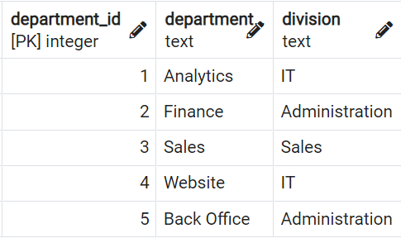

1. INSERT INTO departments
2. VALUES (1, 'Analytics','IT'),
3. (2, 'Finance','Administration'),
4. (3, 'Sales','Sales'),
5. (4, 'Website','IT'),
6. (5, 'Back Office','Administration')

**Task 4**

Difficulty: Moderate

**Task 4.1**

Jack Franklin gets promoted to 'Senior SQL Analyst' and the salary raises to 7200.

Update the values accordingly.

1. UPDATE employees
2. SET position_title = 'Senior SQL Analyst'
3. WHERE emp_id=25;
4. UPDATE employees
5. SET salary=7200
6. WHERE emp_id=25;

**Task 4.2**

The responsible people decided to rename the position_title Customer Support to Customer Specialist.

Update the values accordingly.

1. UPDATE employees
2. SET position_title='Customer Specialist'
3. WHERE position_title='Customer Support';

**Task 4.3**

All SQL Analysts including Senior SQL Analysts get a raise of 6%.

Upate the salaries accordingly.

1. UPDATE employees
2. SET salary=salary*1.06
3. WHERE position_title LIKE '%SQL Analyst';

**Task 4.4**

*Question:*

What is the average salary of a SQL Analyst in the company (excluding Senior SQL Analyst)?

*Answer:*

8834.75

1. SELECT ROUND(AVG(salary),2) FROM employees
2. WHERE position_title='SQL Analyst'

**Task 5**

Difficulty: Advanced

**Task 5.1**

Write a query that adds a column called manager that contains  first_name and last_name (in one column) in the data output.

Secondly, add a column called is_active with 'false' if the employee has left the company already, otherwise the value is 'true'.

1. SELECT
2. emp.*,
3. CASE WHEN emp.end_date IS NULL THEN 'true'
4. ELSE 'false'
5. END as is_active,
6. mng.first_name ||' '|| mng.last_name AS manager_name
7. FROM employees emp
8. LEFT JOIN employees mng
9. ON emp.manager_id=mng.emp_id;

**Task 5.2**

Create a view called v_employees_info from that previous query.

1. CREATE VIEW v_employees_info
2. AS
3. SELECT
4. emp.*,
5. CASE WHEN emp.end_date IS NULL THEN 'true'
6. ELSE 'false'
7. END as is_active,
8. mng.first_name ||' '|| mng.last_name AS manager_name
9. FROM employees emp
10. LEFT JOIN employees mng
11. ON emp.manager_id=mng.emp_id;

**Task 6**

Difficulty: Moderate

Write a query that returns the average salaries for each positions with appropriate roundings.

*Question:*

What is the average salary for a Software Engineer in the company.

*Answer:*

6028.00

1. SELECT
2. position_title,
3. ROUND(AVG(salary),2)
4. FROM v_employees_info
5. GROUP BY position_title
6. ORDER BY 2;

**Task 7**

Difficulty: Moderate

Write a query that returns the average salaries per division.

*Question:*

What is the average salary in the Sales department?

Answer:

6107.41

1. SELECT
2. division,
3. ROUND(AVG(salary),2)
4. FROM employees e
5. LEFT JOIN departments d
6. ON e.department_id=d.department_id
7. GROUP BY division
8. ORDER BY 2

**Task 8**

Difficulty: Advanced

**Task 8.1**

Write a query that returns the following:

emp_id,

first_name,

last_name,

position_title,

salary

and a column that returns the average salary for every job_position.

Order the results by the emp_id.

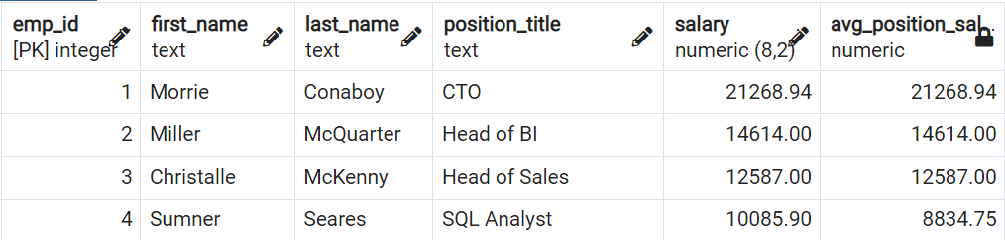

1. SELECT
2. emp_id,
3. first_name,
4. last_name,
5. position_title,
6. salary,
7. ROUND(AVG(salary) OVER(PARTITION BY position_title),2) as avg_position_sal
8. FROM employees
9. ORDER BY 1;

**Task 8.2**

Difficulty: Advanced to Pro

How many people earn less than there avg_position_salary?

Write a query that answers that question.

Ideally, the output just shows that number directly.

*Answer:*

9

1. SELECT
2. COUNT(*)
3. FROM (
4. SELECT
5. emp_id,
6. salary,
7. ROUND(AVG(salary) OVER(PARTITION BY position_title),2) as avg_pos_sal
8. FROM employees) a
9. WHERE salary<avg_pos_sal;

**Task 9:**

Difficulty: Advanced

Write a query that returns a running total of the salary development ordered by the start_date.

In your calculation, you can assume their salary has not changed over time, and you can disregard the fact that people have left the company (write the query as if they were still working for the company).

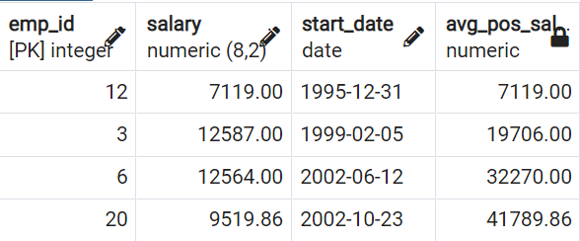

*Question:*

What was the total salary after 2018-12-31?

*Answer:*

180202.70

1. SELECT
2. emp_id,
3. salary,
4. start_date,
5. SUM(salary) OVER(ORDER BY start_date) as salary_totals
6. FROM employees;

**Task 10:**

Difficulty: Pro / Very difficult

Create the same running total but now also consider the fact that people were leaving the company.

*Note:*

This challenge is actually very difficult.

Don't worry if you can't solve it you are not expected to do so.

It is possible to solve the challenge even without the hints.

If you want you can try to solve it using the hints and it is still a difficult challenge.

*Question:*

What was the total salary after 2018-12-31?

*Answer:*

166802.84

*Hint 1:*Use the view v_employees_info.

*Hint 2:*Create two separate queries: one with all employees and one with the people that have already left

*Hint 3:*In the first query use start_date and in the second query use end_date instead of the start_date

*Hint 4:*Multiply the salary of the second query with (-1).

*Hint 5:*Create a subquery from that UNION and use a window function in that to create the running total.

1. SELECT
2. start_date,
3. SUM(salary) OVER(ORDER BY start_date)
4. FROM (
5. SELECT
6. emp_id,
7. salary,
8. start_date
9. FROM employees
10. UNION
11. SELECT
12. emp_id,
13. -salary,
14. end_date
15. FROM v_employees_info
16. WHERE is_active ='false'
17. ORDER BY start_date) a

**Task 11**

Difficulty: Advanced to Pro

**Task 11.1**

Write a query that outputs only the top earner per position_title including first_name and position_title and their salary.

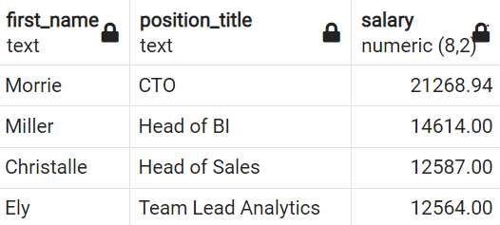

*Question:*

What is the top earner with the position_title SQL Analyst?

*Answer:*

Sumner with 10085.90

1. SELECT
2. first_name,
3. position_title,
4. salary
5. FROM employees e1
6. WHERE salary = (SELECT MAX(salary)
7. FROM employees e2
8. WHERE e1.position_title=e2.position_title)

**Task 11.2**

Add also the average salary per position_title.

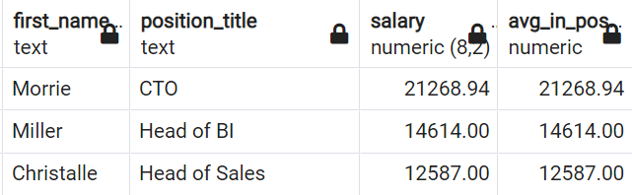

1. SELECT
2. first_name,
3. position_title,
4. salary,
5. (SELECT ROUND(AVG(salary),2) as avg_in_pos FROM employees e3
6. WHERE e1.position_title=e3.position_title)
7. FROM employees e1
8. WHERE salary = (SELECT MAX(salary)
9. FROM employees e2
10. WHERE e1.position_title=e2.position_title)

**Task 11.3**

Remove those employees from the output of the previous query that has the same salary as the average of their position_title.

These are the people that are the only ones with their position_title.

1. SELECT
2. first_name,
3. position_title,
4. salary,
5. (SELECT ROUND(AVG(salary),2) as avg_in_pos FROM employees e3
6. WHERE e1.position_title=e3.position_title)
7. FROM employees e1
8. WHERE salary = (SELECT MAX(salary)
9. FROM employees e2
10. WHERE e1.position_title=e2.position_title)
11. AND salary<>(SELECT ROUND(AVG(salary),2) as avg_in_pos FROM employees e3
12. WHERE e1.position_title=e3.position_title)

**Task 12**

Difficulty: Pro

Write a query that returns all meaningful aggregations of

- sum of salary,

- number of employees,

- average salary

grouped by all meaningful combinations of

- division,

- department,

- position_title.

Consider the levels of hierarchies in a meaningful way.

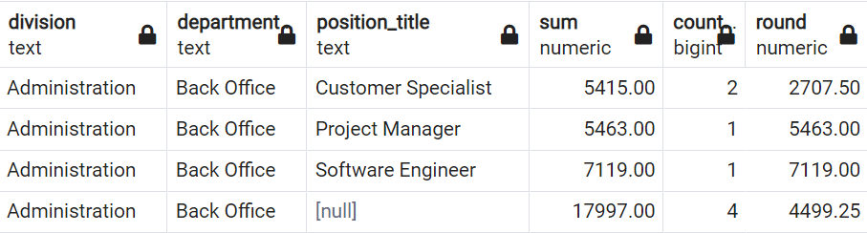

1. SELECT
2. division,
3. department,
4. position_title,
5. SUM(salary),
6. COUNT(*),
7. ROUND(AVG(salary),2)
8. FROM employees
9. NATURAL JOIN departments
10. GROUP BY
11. ROLLUP(
12. division,
13. department,
14. position_title
15. )
16. ORDER BY 1,2,3

**Task 13**

Difficulty: Advanced to Pro

Write a query that returns all employees (emp_id) including their position_title, department, their salary, and the rank of that salary partitioned by department.

The highest salary per division should have rank 1.

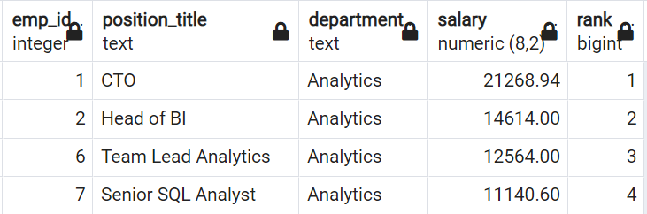

*Question:*

Which employee (emp_id) is in rank 7 in the department Analytics?

*Answer:*

emp_id 26

1. SELECT
2. emp_id,
3. position_title,
4. department,
5. salary,
6. RANK() OVER(PARTITION BY department ORDER BY salary DESC)
7. FROM employees
8. NATURAL LEFT JOIN departments

**Task 14**

Difficulty: Pro

Write a query that returns only the top earner of each department including

their emp_id, position_title, department, and their salary.

*Question:*

Which employee (emp_id) is the top earner in the department Finance?

*Answer:*

emp_id 8

1. SELECT * FROM
2. (
3. SELECT
4. emp_id,
5. position_title,
6. department,
7. salary,
8. RANK() OVER(PARTITION BY department ORDER BY salary DESC)
9. FROM employees
10. NATURAL LEFT JOIN departments) a
11. WHERE rank=1